Announcements:
Sunday, March 1
10:00 am Worship Service
Monday, February 2
5:00 pm Choir Practice
7:45 pm Serving @ St. Benedict’s
Tuesday, March 3
5:00 pm Finance Committee Meeting
Saturday, March 7
Spring Forward—Daylight Savings Begins
Sunday, March 8
9:00 am Sunday School
10:00 am Worship Service
Monday, February 9
5:00 pm Choir Practice
Tuesday, March 10
4:00 pm UWF Meeting

Prelude: Lighting of the Candles
Greetings and Announcements
*Song of Welcome: Savior, Like a Shepherd Lead Us
(all verses) p.381
*Call to Worship: Apostle’s Creed p.881
Praises
*Hymn of Praise: More Love to Thee, O Christ
(v1,2,&3) p.453
Anthem: St. John Choir
Children’s Moment: Star Ralph
*Greet Your Neighbor: Pass the Peace of Christ
Prayer Concerns
Pastoral Prayer & The Lord’s Prayer
Giving of Tithes and Offerings
*People’s Response: Doxology p.95
Scripture: Genesis 12: 1-4 Tony Minton
Sermon: Pastor Chris Toney
*Hymn of Reflection: Grace Greater than Our Sin
(v1) p.365
*Sending Forth
*Postlude
*Congregation Standing
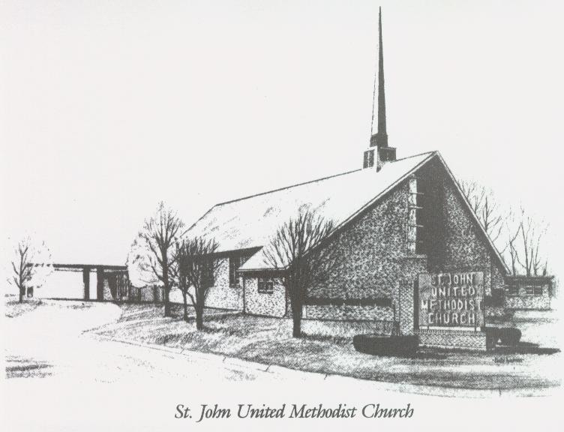

March 1, 2026

Church 270-683-6326
Secretary:270-316-0709
Email: office@stjohnum.org
Pastor: Chris Toney
(304) 704-2910

Sunday School – 9:00 a.m. Sunday Worship – 10:00 a.m.
Lay Leader – Sondra Jones
Director of Music – Sharon Sauer
Pianist – Marty Shively
Liturgist – Tony Minton
Media Tech – Daniel Gray
Bishop – David Graves Dist. Supt. – Wade Arp
Secretary—Sondra Jones
S
S
INVITE~~RELATE~~NURTURE~~SEND FORTH
Our mission at St. John United Methodist Church
is to discover and invite all persons,
to relate them to Jesus Christ,
to nurture them in faith,
and to send them out to live as disciples,
making the community and
the world a better place to live.

