Announcements:
Sunday, March 29, Palm Sunday
10:00 am Worship Service, Easter Cantata
Monday, March 30
5:00 pm Choir Practice
Wednesday, April 1
5:00 pm Mega Media Task Force Mtg.
Thursday, April 2
5:00 pm Maundy Thursday Service, Communion
Friday, April 3 Good Friday
Sunday, April 5, Easter Sunday
9:00 am Sunday School
10:00 am Worship Service
Monday, April 6
5:00 pm Choir Practice
7:45 Serving @ St. Benedict’s
Tuesday, April 7
4:00 pm UWF Meeting
Wednesday, April 8
5:00 pm ‘Continue Easter Celebration’ Potluck

**Be sure to get your picture made for the directory before church and update your information!

Prelude: Lighting of the Candles
Greetings and Announcements
*Song of Welcome: Hosanna, Loud Hosanna
(v1&2) p.278
Rejoice, the Lord Is King Medley
His Triumphant Entrance Medley
The Darkest Night Underscore
Giving of Tithes and Offerings
*People’s Response: Doxology p.95

The Day He Wore My Crown
Written in Red
The Living One
Jesus, We Crown You with Praise
The King is Coming w/Amazing Grace
*Hymn of Reflection: In the Garden
(v3) p.314
*Sending Forth
*Postlude
*Congregation Standing
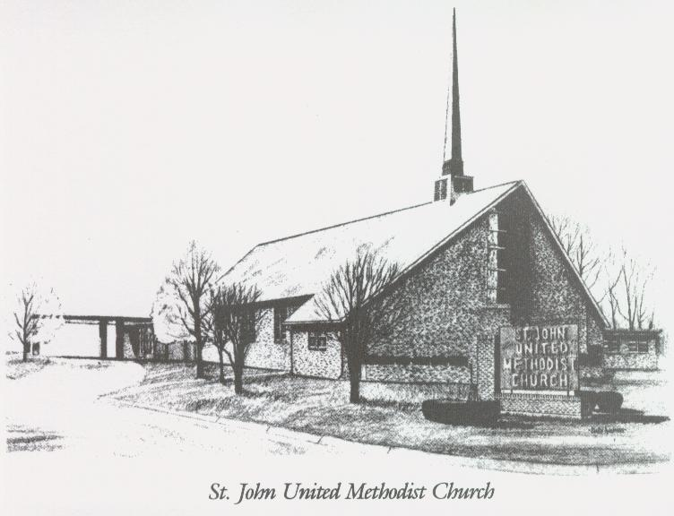

March 29, 2026

Church 270-683-6326
Secretary:270-316-0709
Email: office@stjohnum.org
Pastor: Chris Toney
(304) 704-2910

Sunday School – 9:00 a.m. Sunday Worship – 10:00 a.m.
Lay Leader – Sondra Jones
Director of Music – Sharon Sauer
Pianist – Marty Shively
Liturgist – Tony Minton
Media Tech – Daniel Gray
Bishop – David Graves Dist. Supt. – Wade Arp
Secretary—Sondra Jones
S
S
INVITE~~RELATE~~NURTURE~~SEND FORTH
Our mission at St. John United Methodist Church
is to discover and invite all persons,
to relate them to Jesus Christ,
to nurture them in faith,
and to send them out to live as disciples,
making the community and
the world a better place to live.

