Announcements:
Sunday, May 10, Mother’s Day
10:00 am Worship Service
Monday, May 11
5:00 pm Choir Practice
Saturday, May 16
8:30 am Methodist Men’s Breakfast
Sunday, May 17
9:00 am Sunday School
10:00 am Worship Service
Monday, May 18
5:00 pm Choir Practice
Tuesday, May 19
4:00 pm Family Life Com. Meeting
Wednesday, May 20
11:30 am St. John Singles Lunch @ Yummy Bowl on Frederica St.

Prelude: Lighting of the Candles
Greetings and Announcements
*Song of Welcome: Joyful, Joyful, We Adore Thee
(all verses) p.89
*Call to Worship: Apostle’s Creed p.881
Praises
*Hymn of Praise: Come, We That We That Love the Lord
(all verses) p.732
Special Music: Sebastian Huffman & Marty Shively
Children’s Moment: Star Ralph
*Greet Your Neighbor: Pass the Peace of Christ
Prayer Concerns
Pastoral Prayer & The Lord’s Prayer
Giving of Tithes and Offerings
*People’s Response: Doxology p.95
Scripture: 2 Timothy 1: 3-7 Tony Minton
Sermon: Pastor Chris Toney
*Hymn of Reflection: Sweet Hour of Prayer
(v1) p.496
*Postlude
*Congregation Standing
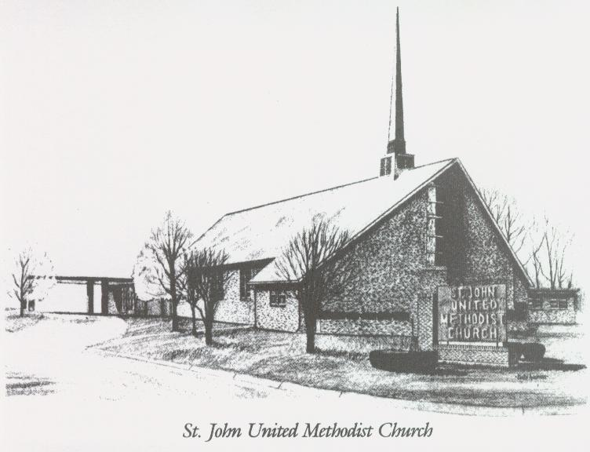

May 10, 2026

Church 270-683-6326
Secretary:270-316-0709
Email: office@stjohnum.org
Pastor: Chris Toney
(304) 704-2910

Sunday School – 9:00 a.m. Sunday Worship – 10:00 a.m.
Lay Leader – Sondra Jones
Director of Music – Sharon Sauer
Pianist – Marty Shively
Liturgist – Tony Minton
Media Tech – Daniel Gray
Bishop – David Graves Dist. Supt. – Wade Arp
Secretary—Sondra Jones
S
S
INVITE~~RELATE~~NURTURE~~SEND FORTH
Our mission at St. John United Methodist Church
is to discover and invite all persons,
to relate them to Jesus Christ,
to nurture them in faith,
and to send them out to live as disciples,
making the community and
the world a better place to live.

