Announcements:
Sunday, May 31
10:00 am Worship Service
Monday, June 1
5:00 pm Choir Practice
7:45 pm Serving @ St. Benedict’s
Tuesday, June 2
4:00 pm UWF Meeting
Wednesday, June 3
5:00 pm VBS Meeting
Sunday, June 7, Communion Sunday
9:00 am Sunday School
10:00 am Worship Service
Monday, June 8
5:00 pm Choir Practice
Wednesday, June 10
5:00 pm Mega Media Meeting

Prelude: Lighting of the Candles
Greetings and Announcements
*Song of Welcome: Here I Am, Lord
(all verses) p.593
*Call to Worship: Apostle’s Creed p.881
Praises
*Hymn of Praise: The Gift of Love(all verses) p.408
Anthem: St. John Choir
Children’s Moment: Star Ralph
*Greet Your Neighbor: Pass the Peace of Christ
Prayer Concerns
Pastoral Prayer & The Lord’s Prayer
Giving of Tithes and Offerings
*People’s Response: Doxology p.95
Scripture: 2 Corinthians 13: 11-14 Tony Minton
Sermon: Pastor Chris Toney
*Hymn of Reflection: What Wondrous Love Is This
(v3) p.292
*Sending Forth
*Postlude
*Congregation Standing
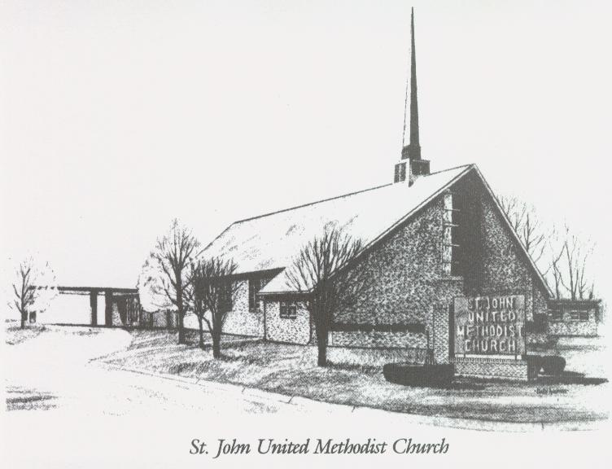

May 31, 2026

Church 270-683-6326
Secretary:270-316-0709
Email: office@stjohnum.org
Pastor: Chris Toney
(304) 704-2910

Sunday School – 9:00 a.m. Sunday Worship – 10:00 a.m.
Lay Leader – Sondra Jones
Director of Music – Sharon Sauer
Pianist – Marty Shively
Liturgist – Tony Minton
Media Tech – Daniel Gray
Bishop – David Graves Dist. Supt. – Wade Arp
Secretary—Sondra Jones
S
S
INVITE~~RELATE~~NURTURE~~SEND FORTH
Our mission at St. John United Methodist Church
is to discover and invite all persons,
to relate them to Jesus Christ,
to nurture them in faith,
and to send them out to live as disciples,
making the community and
the world a better place to live.

