Announcements:
Sunday, June 7, Communion Sunday
Monday, June 8
No Choir Practice
Wednesday, June 10
4:00 pm Mega Media Meeting
Sunday, June 14
9:00 am Sunday School
10:00 am Worship Service
Monday, June 15
No Choir Practice
Tuesday, June 16
5:00 pm Family Life Meeting
Wednesday, June 17
11:30 am St. John Singles Lunch @ Shiloh’s Lounge (OId 8 Ball Restaurant)
5:00 pm VBS Meeting
Saturday, June 20
8:30 am Methodist Men’s Breakfast (Men cook but all are invited to eat!)

Prelude: Lighting of the Candles
Greetings and Announcements
*Song of Welcome: Do, Lord, Remember Me
(v1,2,&5) p.527
*Call to Worship: Apostle’s Creed p.881
Praises
*Hymn of Praise: Spirit Song(All Verses) p.347
Anthem: St. John Choir
Holy Communion p.13
Children’s Moment: Star Ralph
*Greet Your Neighbor: Pass the Peace of Christ
Prayer Concerns
Pastoral Prayer & The Lord’s Prayer
Giving of Tithes and Offerings
*People’s Response: Doxology p.95
Scripture: Matthew 9: 18-26 Tony Minton
Sermon: Pastor Chris Toney
*Hymn of Reflection: Just as I Am, Without One Plea
(v6) p.357
*Sending Forth
*Postlude
*Congregation Standing
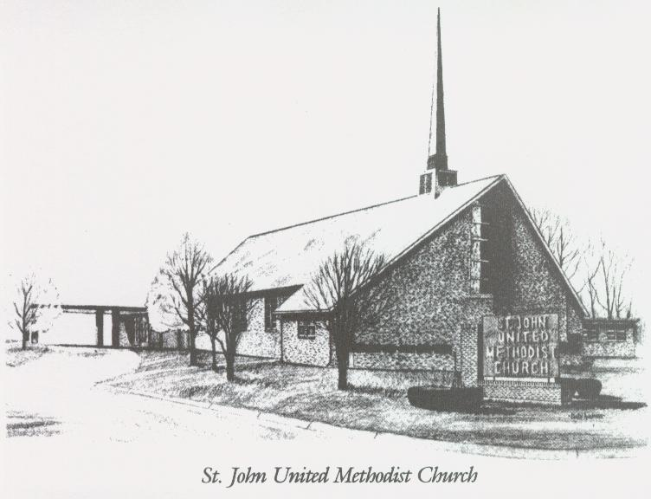

June 7, 2026

Church 270-683-6326
Secretary:270-316-0709
Email: office@stjohnum.org
Pastor: Chris Toney
(304) 704-2910

Sunday School – 9:00 a.m. Sunday Worship – 10:00 a.m.
Lay Leader – Sondra Jones
Director of Music – Sharon Sauer
Pianist – Marty Shively
Liturgist – Tony Minton
Media Tech – Daniel Gray
Bishop – David Graves Dist. Supt. – Wade Arp
Secretary—Sondra Jones
S
S
INVITE~~RELATE~~NURTURE~~SEND FORTH
Our mission at St. John United Methodist Church
is to discover and invite all persons,
to relate them to Jesus Christ,
to nurture them in faith,
and to send them out to live as disciples,
making the community and
the world a better place to live.

