Announcements:
Sunday, July 12
Monday, July 13
2-4 pm VBS Decoration building
5:00 pm Choir Practice
Tuesday, July 14
10 am-2 pm VBS Decoration building
Wednesday, July 15
10 am-2 pm VBS Decoration building
11:30 am St. John Singles Lunch @ Gusto’s Restaurant
5:00 pm VBS Meeting
Thursday, July 16
10 am-2 pm VBS Decoration building
Saturday, July 18
8:30 am Methodist Men’s Community Breakfast
Sunday, July 19
9:00 am Sunday School
10:00 am Worship Service
Monday, July 20
5:00 pm Choir Practice
3:00-6:00 pm VBS Decorating, as needed
Tuesday, July 21
August Satellite Items Due
3:00-6:00 pm VBS Decorating, as needed
5:00 pm Family Life Meeting
Wednesday, July 22-24
9 am – 12 pm VBS Snowball Mountain Challenge

Prelude: Lighting of the Candles
Greetings and Announcements
*Song of Welcome: O For a Thousand Tongues to Sing
(v1-4) p.57
*Call to Worship: Apostle’s Creed p.881
Praises
*Hymn of Praise: Holy, Holy, Holy! Lord God Almighty
(v1,2,&4) p.64
Anthem: St. John Choir
Children’s Moment: Sondra Jones
*Greet Your Neighbor: Pass the Peace of Christ
Prayer Concerns
Pastoral Prayer & The Lord’s Prayer
Giving of Tithes and Offerings
*People’s Response: Doxology p.95
Scripture: Matthew 13:1-9, 18-23 Tony Minton
Sermon: Pastor Chris Toney
*Hymn of Reflection: Softly and Tenderly Jesus Is Calling
(v4) p.348
*Sending Forth
*Congregation Standing
*Postlude
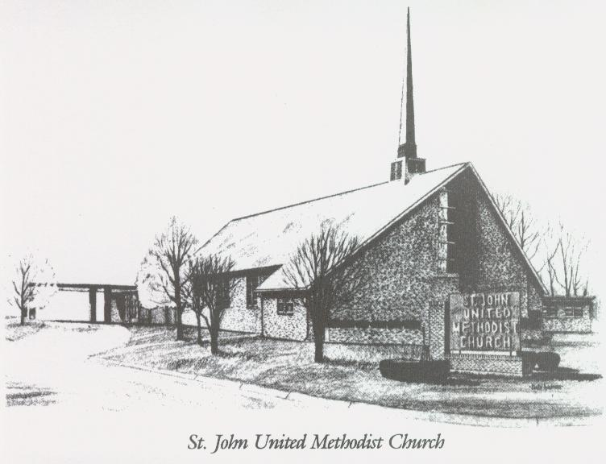

July 12, 2026

Church 270-683-6326
Secretary:270-316-0709
Email: office@stjohnum.org
Pastor: Chris Toney
(304) 704-2910

Sunday School – 9:00 a.m. Sunday Worship – 10:00 a.m.
Lay Leader – Sondra Jones
Director of Music – Sharon Sauer
Pianist – Marty Shively
Liturgist – Tony Minton
Media Tech – Daniel Gray
Bishop – David Graves Dist. Supt. – Wade Arp
Secretary—Sondra Jones
S
S
INVITE~~RELATE~~NURTURE~~SEND FORTH
Our mission at St. John United Methodist Church
is to discover and invite all persons,
to relate them to Jesus Christ,
to nurture them in faith,
and to send them out to live as disciples,
making the community and
the world a better place to live.

