Announcements:
Sunday, August 2
Holy Communion
Monday, August 3
5:00 pm Administrative Board Meeting
7:45 pm Serving @ St. Benedict’s
Tuesday, August 4
4:00 pm UWF Meeting
Sunday, August 9
9:00 am Sunday School
10:00 am Worship Service, Blessing of the Backpacks
11:00 am Potluck (Bring a dish to share!)
Monday, August 10
5:00 pm Choir Practice
Saturday, August 15
8:30 am Methodist Men’s Community Breakfast
** We are going to launch our Assisted Hearing System on August 9th.
Headsets will be available to use at the morning service. If you need help with syncing your hearing aids or iPods, please see Danny or Marty after the service on the 9th.
Prelude: Lighting of the Candles
Greetings and Announcements
*Song of Welcome: Wonderful Words of Life
(v1&3) p.600
*Call to Worship: Apostle’s Creed p.881
Praises
*Hymn of Praise: Let Us Break Bread Together
(All verses) p.618
Anthem: St. John Choir
Holy Communion p.13
Children’s Moment: Star Ralph
*Greet Your Neighbor: Pass the Peace of Christ
Prayer Concerns
Pastoral Prayer & The Lord’s Prayer
Giving of Tithes and Offerings
*People’s Response: Doxology p.95
Scripture: Matthew 14: 13-21 Tony Minton
Sermon: Pastor Chris Toney
*Hymn of Reflection: Sent Forth by God’s Blessing
(v1) p.664
*Sending Forth
*Congregation Standing
*Postlude
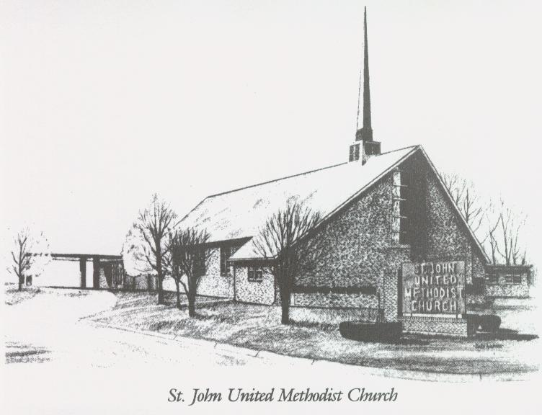

August 2, 2026

Church 270-683-6326
Secretary:270-316-0709
Email: office@stjohnum.org
Pastor: Chris Toney
(304) 704-2910

Sunday School – 9:00 a.m. Sunday Worship – 10:00 a.m.
Lay Leader – Sondra Jones
Director of Music – Sharon Sauer
Pianist – Marty Shively
Liturgist – Tony Minton
Media Tech – Daniel Gray
Bishop – David Graves Dist. Supt. – Wade Arp
Secretary—Sondra Jones
S
S
INVITE~~RELATE~~NURTURE~~SEND FORTH
Our mission at St. John United Methodist Church
is to discover and invite all persons,
to relate them to Jesus Christ,
to nurture them in faith,
and to send them out to live as disciples,
making the community and
the world a better place to live.

