Announcements:
Sunday, August 23
10:00 am Worship Service
Monday, August 24
5:00 pm Choir Practice
Tuesday, August 25
September Satellite Items Due
5:00 Supper Club @ Briarpatch
Sunday, August 30
9:00 am Sunday School
10:00 am Worship Service
Monday, August 31
5:00 pm Choir Practice
Tuesday, September 1
4:00 pm UWF

** Please see Danny or Marty if you have questions about assisted hearing devices. They are now available.
Prelude: Lighting of the Candles
Greetings and Announcements
*Song of Welcome: Help Us Accept Each Other
(All verses) p.560
*Call to Worship: Apostle’s Creed p.881
Praises
*Hymn of Praise: Softly and Tenderly Jesus Is Calling
(v1&4) p.348
Anthem: St. John Choir
Children’s Moment: Star Ralph
*Greet Your Neighbor: Pass the Peace of Christ
Prayer Concerns
Pastoral Prayer & The Lord’s Prayer
Giving of Tithes and Offerings
*People’s Response: Doxology p.95
Scripture: Matthew 16: 13-20 Tony Minton
Sermon: Pastor Chris Toney
*Hymn of Reflection: Just as I Am, Without One Plea
(v1) p.357
*Sending Forth
*Congregation Standing
*Postlude
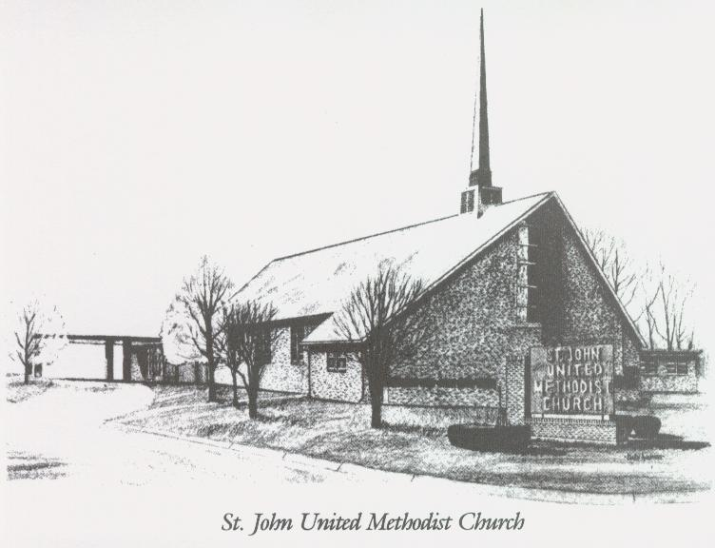

August 23, 2026

Church 270-683-6326
Secretary:270-316-0709
Email: office@stjohnum.org
Pastor: Chris Toney
(304) 704-2910

Sunday School – 9:00 a.m. Sunday Worship – 10:00 a.m.
Lay Leader – Sondra Jones
Director of Music – Sharon Sauer
Pianist – Marty Shively
Liturgist – Tony Minton
Media Tech – Daniel Gray
Bishop – David Graves Dist. Supt. – Wade Arp
Secretary—Sondra Jones
S
S
INVITE~~RELATE~~NURTURE~~SEND FORTH
Our mission at St. John United Methodist Church
is to discover and invite all persons,
to relate them to Jesus Christ,
to nurture them in faith,
and to send them out to live as disciples,
making the community and
the world a better place to live.

