Announcements:
Sunday, September 1
Communion Sunday
Monday, September 2
Labor Day
7:45 pm Serving @ St. Benedict’s
Tuesday, September 3
9 am - 12 pm UWF District Meeting
Sunday, September 8
Grandparent’s Day
9:00 am Sunday School
10:00 am Worship Service
Thursday, September 12
Shirt/Money Order Due
4:00 pm Craft Fair/Car Show Meeting

**No Methodist Men’s Breakfast on Sept. 21st due to Craft Fair and Car Show.
Prelude: Lighting of the Candles
Greetings and Announcements
*Song of Welcome: Morning Has Broken(v1&3) p145
*Call to Worship: Apostle’s Creed p.881
Praises
*Hymn of Praise: The Church’s One Foundation
(v1,2,&4) p.545
Anthem: St. John’s Choir
Communion p.13
Children’s Moment: Star Ralph
*Greet Your Neighbor: Pass the Peace of Christ
Prayer Concerns
Pastoral Prayer & The Lord’s Prayer
Giving of Tithes and Offerings
*People’s Response: Doxology p.95

Scripture Reading: Mark 7: 1-8, 21-23 Tony Minton
Sermon: Pastor Chris Toney
*Hymn of Reflection: Let There Be Peace on Earth p.431
*Sending Forth
*Congregation Standing
*Postlude
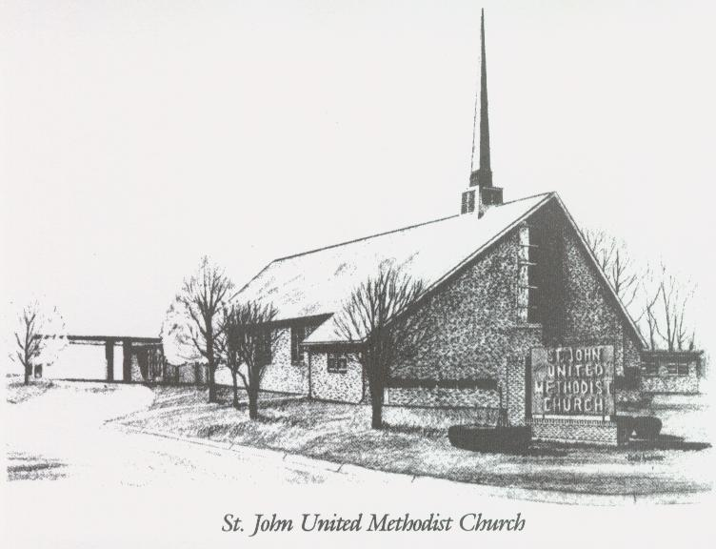

September 1, 2024

Church 270-683-6326
Email: office@stjohnum.org
Website: stjohnum.org
Pastor: Chris Toney
304-704-2910

Sunday School – 9:00 a.m. Sunday Worship – 10:00 a.m.
Lay Leader – Sondra Jones
Director of Music – Aaron Lundy
Organist – Ila Culp Pianist – Marty Shively
Liturgist – Tony Minton
Media Tech – Daniel Gray
Bishop – David Graves Dist. Supt. – Jay Smith
Secretary—Sondra Jones
S
INVITE~~RELATE~~NURTURE~~SEND FORTH
Our mission at St. John United Methodist Church
is to discover and invite all persons,
to relate them to Jesus Christ,
to nurture them in faith,
and to send them out to live as disciples,
making the community and
the world a better place to live.

