Announcements:
Monday, October 3
5:00 pm, Admin Board Meeting
Tuesday, October 4
4:00 pm, Women in Faith
5:00 pm, Family Life
6:30 pm, Boulware
Wednesday, October 5
11:00 am, KWC Chapel
Thursday, October 13
10:30 am, Membership
4:30 pm, Membership
Friday, October 14
6:00 pm, Trivia Night
Saturday, October 15
8:30 am, MM Breakfast
****WELCOME NEW MEMBERS**** TERRY AND STARR RALPH
*Nursery Workers still needed! Sign-up sheet outside the church office. Bell ringers see Sarah or Vicki Hast

Prelude: Lighting of the Candles
Welcoming Hymn: There’s Within My Heart a Melody
p.380
Welcome
*Call to Worship:Whether Word be Preached or Readp.595
*Hymn of Praise: Rise up, O Men of God p.576
*Greet Your Neighbor: Pass the Peace of Christ
(Wave to, shout “hello” or elbow bump your neighbor)
Announcements
Prayers and Praises
The Lord’s Prayer
Offertory Hymn:Since Jesus Came into My Heart p.503
(Giving of gifts & tithes)
*People’s Response: Doxology p.95
Anthem: New Life Medley
Children’s Service Starr Ralph
Scripture Reading: Rev. 3:7-13 Tony Minton
Sermon: The Open Door Pastor Mickey
Celebration Communion
*Hymn of Reflection: Softly and Tenderly p.348
*Pastoral Benediction
*People’s Response: Turn Your Eyes upon Jesus p.349
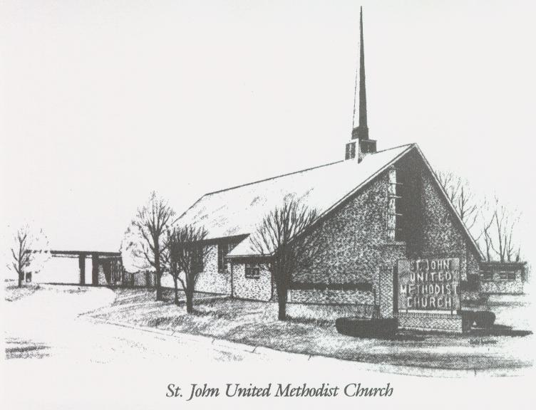
October 2nd, 2022
The Open Door

Rev. Mickey Richardson, Pastor
Cell: 502-409-1482
Church 270-683-6326
Email: office@stjohnum.org

Sunday School – 9:00 a.m. Sunday Worship – 10:00 a.m.
Lay Leader – Dana Gray
Director of Music – Sarah Elliott
Organist – Ila Culp Pianist – Marty Shively
Liturgist – Tony Minton
Media Tech – Ryan Gray Associate MT – Daniel Gray
Bishop – Leonard Fairley Dist. Supt. – JaySmith
Secretary – Amber Wilson

INVITE~~RELATE~~NURTURE~~SEND FORTH
Our mission at St. John United Methodist Church
is to discover and invite all persons,
to relate them to Jesus Christ,
to nurture them in faith,
and to send them out to live as disciples,
making the community and
the world a better place to live.

