Announcements:
Wednesday, October 12
5:00 pm, Choir Practice
Thursday, October 13
10:30 am, Membership Class
4:30 pm, Membership Class
Friday, October 14
6:00 pm, Trivia Night-postponed to another date
Saturday, October 15
8:30 am, MM Breakfast
Sunday, October 16
Laity Sunday
Handout Harvest Bags
Wednesday, October 19
5:00 pm, Choir Practice
Thursday, October 20
10:30 am, Membership Class
4:30 pm, Membership Class

*Nursery Workers still needed! Sign-up sheet outside the church office. Bell ringers see Sarah or Vicki Hast

Prelude: Lighting of the Candles
Welcoming Hymn: There’s Within My Heart a Melody(chorus)
p.380
Welcome
*Call to Worship: Where Shall My Wondering Soul Begin?
p.342
*Hymn of Praise: Crown Him with Many Crowns(all)p.327
*Greet Your Neighbor: Pass the Peace of Christ
(Wave to, shout “hello” or elbow bump your neighbor)
Announcements
Prayers and Praises
The Lord’s Prayer
Offertory Hymn: O Jesus, I Have Promised (v.1-2-4) p.396
(Giving of gifts & tithes)
*People’s Response: Doxology p.95
Anthem: We’ve a Story to Tell to the Nation
Children’s Service Starr Ralph
Scripture Reading: Matthew 28:16-20 Tony Minton
Sermon: The Butterfly Church Pastor Mickey
*Hymn of Reflection: Freely, Freely (v.1) p.389
*Pastoral Benediction
*People’s Response: Abide with Me (v.1) p.700
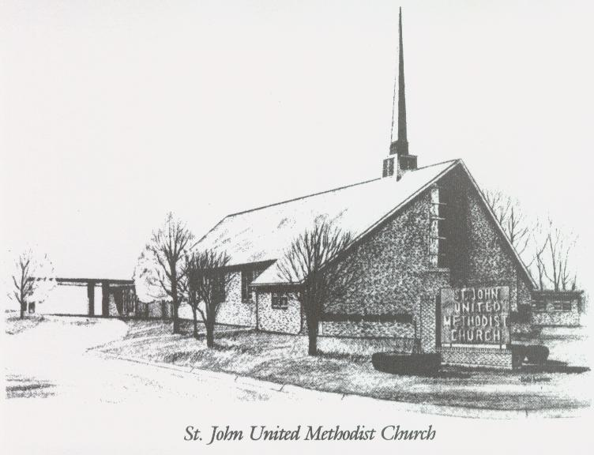
October 9th, 2022
The Butterfly Church

Rev. Mickey Richardson, Pastor
Cell: 502-409-1482
Church 270-683-6326
Email: office@stjohnum.org

Sunday School – 9:00 a.m. Sunday Worship – 10:00 a.m.
Lay Leader – Dana Gray
Director of Music – Sarah Elliott
Organist – Ila Culp Pianist – Marty Shively
Liturgist – Tony Minton
Media Tech – Ryan Gray Associate MT – Daniel Gray
Bishop – Leonard Fairley Dist. Supt. – JaySmith

INVITE~~RELATE~~NURTURE~~SEND FORTH
Our mission at St. John United Methodist Church
is to discover and invite all persons,
to relate them to Jesus Christ,
to nurture them in faith,
and to send them out to live as disciples,
making the community and
the world a better place to live.

