Announcements:
Sunday, November 23
10:00 am Worship Service
Monday, November 24
Satellite Items Due
4:00 pm Decorating the Church
5:00 pm Choir Practice
Tuesday, November 25
5:00 pm Supper Club @ Moonlite
Thursday, November 27
Happy Thanksgiving
Sunday, November 30
9:00 am Sunday School
10:00 am Worship Service
5:00 pm Hanging of the Greens Service
6:00 pm Church-wide Christmas Party
Monday, December 1
5:00 pm Choir Practice
7:45 pm Serving @ St. Benedict’s
Tuesday, December 2
4:00 pm UWF Meeting

Prelude: Lighting of the Candles
Greetings and Announcements
*Song of Welcome: Crown Him with Many Crowns
(v1,&3) p.327
*Call to Worship: Apostle’s Creed p.881
Praises
*Hymn of Praise: Lift High the Cross(v1,3,&4) p.159
Anthem: St. John Choir
Children’s Moment: Star Ralph
*Greet Your Neighbor: Pass the Peace of Christ
Prayer Concerns
Pastoral Prayer & The Lord’s Prayer
Giving of Tithes and Offerings
*People’s Response: Doxology p.95
Scripture: Colossians 1: 11-20 Tony Minton
Sermon: Pastor Chris Toney
*Hymn of Reflection: Now Thank We All Our God
(v1) p.102
*Sending Forth
*Postlude
*Congregation Standing
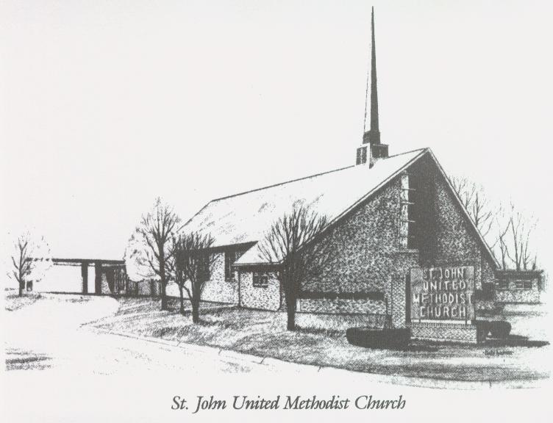

November 23, 2025

Church 270-683-6326
Email: office@stjohnum.org
Pastor: Chris Toney
(304) 704-2910

Sunday School – 9:00 a.m. Sunday Worship – 10:00 a.m.
Lay Leader – Sondra Jones
Director of Music – Sharon Sauer
Pianist – Marty Shively
Liturgist – Tony Minton
Media Tech – Daniel Gray
Bishop – David Graves Dist. Supt. – Wade Arp
Secretary—Sondra Jones
S
S
INVITE~~RELATE~~NURTURE~~SEND FORTH
Our mission at St. John United Methodist Church
is to discover and invite all persons,
to relate them to Jesus Christ,
to nurture them in faith,
and to send them out to live as disciples,
making the community and
the world a better place to live.

