Announcements:
Sunday, December 1, 1st Sunday of Advent
2:00 pm Decorating of the Church
5:00 pm Hanging of the Greens Service
6:00 pm Church Christmas Party
Monday, December 2
7:45 pm Serving @ St. Benedict’s
Wednesday, December 3
5:00 pm Choir Practice
Sunday, December 8, 2nd Sunday of Advent
9:00 am Sunday School
10:00 am Worship Service
Monday, December 9
8:00 am Mountain Mission Pick-up
Wednesday, December 11
5:00 pm Choir Practice

**Bring a Fun, Finger food to share to the Christmas Party tonight after the Hanging of the Greens Service!! See you there.

Prelude: Lighting of the Candles
Greetings and Announcements
Lighting of the Advent Candle
*Song of Welcome: O Come, O Come, Emmanuel
(v1,2,&3) p.211
*Call to Worship: Apostle’s Creed p.881
Praises
*Hymn of Praise: Lift Up Your Heads, Ye Mighty Gates
(v 1,2,&3) p.213
Anthem: St. John UMC Choir
Children’s Moment: Star Ralph
*Greet Your Neighbor: Pass the Peace of Christ
Prayer Concerns
Pastoral Prayer & The Lord’s Prayer
Giving of Tithes and Offerings
*People’s Response: Doxology p.95
Scripture: Mark 13 :24-37 Tony Minton
Sermon: Pastor Chris Toney
*Hymn of Reflection: Soon and Very Soon(v1&2) p.706
*Sending Forth
*Postlude
*Congregation Standing
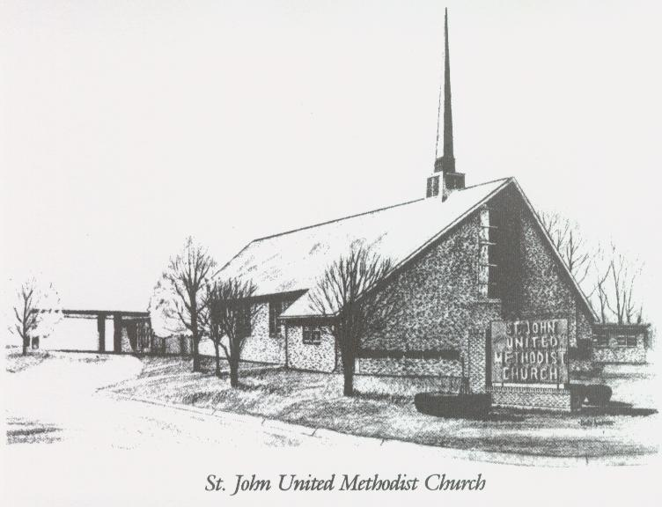

December 1, 2024

Church 270-683-6326
Email: office@stjohnum.org
Website: stjohnum.org
Pastor: Chris Toney
304-704-2910

Sunday School – 9:00 a.m. Sunday Worship – 10:00 a.m.
Lay Leader – Sondra Jones
Director of Music – Aaron Lundy
Organist – Ila Culp Pianist – Marty Shively
Liturgist – Tony Minton
Media Tech – Daniel Gray
Bishop – David Graves Dist. Supt. – Jay Smith
Secretary—Sondra Jones
S
INVITE~~RELATE~~NURTURE~~SEND FORTH
Our mission at St. John United Methodist Church
is to discover and invite all persons,
to relate them to Jesus Christ,
to nurture them in faith,
and to send them out to live as disciples,
making the community and
the world a better place to live.

