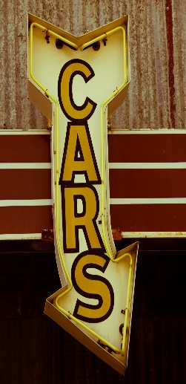
Classic Car Show
St. John United Methodist Church
2160 Griffith Ave.
October 28, 2023
10:00 a.m. – 2:00 p.m.
We will have trophies for:
- BEST IN SHOW
- PEOPLE’S CHOICE
- BEST FORD
- BEST CHEVY
- BEST MOPAR
- BEST JEEP
- BEST FOREIGN CAR
- BEST CORVETTE
- BEST MUSTANG

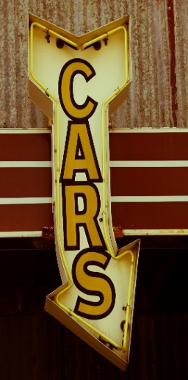
CAR SHOW JUDGED BY:

Registration fee is a donation to Help Office.
50/50 Pot—Half goes to St. Benedict’s.
Call 270-302-7648 for more information.
Craft Fair with Silent Auction, Sweet Shop, Homemade Crafts, Bean Soup, Cornbread, Burgers & Hotdogs is the same day!
Vendor Space Available! (270-302-4999)

