Announcements:
Sunday, March 19, Fourth Sunday of Lent
10:00 am Worship Service
Tuesday, March 21
4:00 pm Family Life Committee Meeting
Wednesday, March 22
Items for Satellite due to Office
4:00 pm Bible Study with Rev. Dave
4:45 pm Choir Practice
5:30 pm Confirmation Class
Sunday, March 26, Fifth Sunday of Lent
9:00 am Sunday School
10:00 am Worship Service
Tuesday, March 28
5:00 pm Supper Club @ Old Hickory
Wednesday, March 29
4:00 pm Bible Study with Rev. Dave
4:45 pm Choir Practice
5:30 pm Confirmation Class

Prelude: Lighting of the Candles
Song of Welcome: I Stand Amazed in the Presence
(Chorus) p.354
Greetings and Announcements
Praises
*Call to Worship: Apostle’s Creed p.881
*Hymn of Praise We’ll Understand It Better By and By
(v1,3,&4) p.525
*Greet Your Neighbor: Pass the Peace of Christ
Prayers Concerns
Pastoral Prayer & The Lord’s Prayer
Giving of Tithes and Offerings
*People’s Response: Doxology p.95
Anthem: St. John’s Choir Children’s Moment: Sondra Jones

Scripture Reading: Romans 3:21-31 Tony Minton
Sermon: "Preach to Them" Reverend Dave Turner * *Hymn of Reflection: Breathe on Me, Breath of God
(v1&4) p.420
*Sending Forth
*Postlude

*Congregation Standing
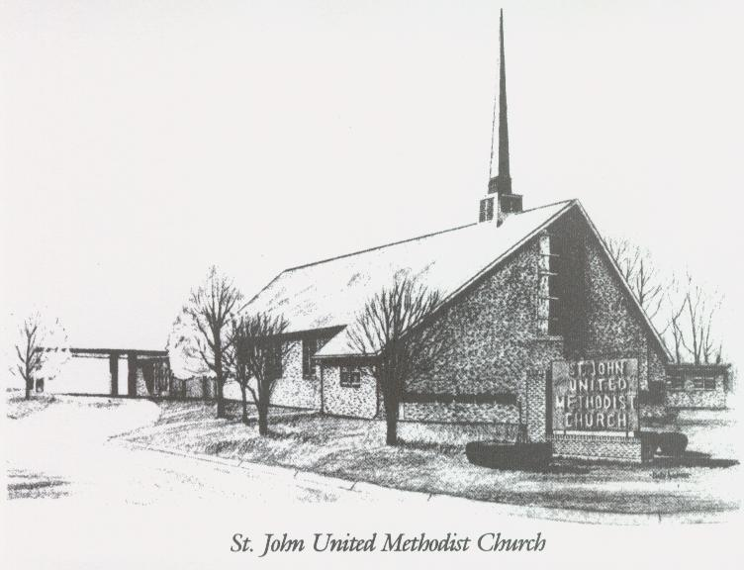
March 19, 2023
“PREACH TO THEM”
Church 270-683-6326
Email: office@stjohnum.org
Pastor: David Turner
270-350-5360

Sunday School – 9:00 a.m. Sunday Worship – 10:00 a.m.
Lay Leader – Dana Gray
Director of Music – Sarah Elliott
Organist – Ila Culp Pianist – Marty Shively
Liturgist – Tony Minton
Media Tech – Ryan Gray Associate MT – Daniel Gray
Bishop – Leonard Fairley Dist. Supt. – Jay Smith
Secretary—Sondra Jones
S
INVITE~~RELATE~~NURTURE~~SEND FORTH
Our mission at St. John United Methodist Church
is to discover and invite all persons,
to relate them to Jesus Christ,
to nurture them in faith,
and to send them out to live as disciples,
making the community and
the world a better place to live.

