Announcements:
Sunday, April 21
10:00 am Worship Service
3-5pm Game Night
Monday, April 22
4:00 pm Family Worship Comm. Mtg.
Tuesday, April 23
5:00 pm Supper Club @ Cracker Barrel
Wednesday, April 24
5:00 pm Choir Practice
May Satellite Items Due
Sunday, April 28
9:00 am Sunday School
10:00 am Worship Service
Wednesday, May 1
5:00 pm Choir Practice
**It is not too late to sign up for game night. Sign-up sheet is in the Narthex. Feel free to sign up and come play some games!!

Prelude: Lighting of the Candles
Greetings and Announcements
*Song of Welcome: Lift High the Cross(all) p.159
*Call to Worship: Apostle’s Creed p.881
Praises
*Hymn of Praise: Savior, Like a Shepherd Lead Us(all) p.381
Anthem: Victory In Jesus St. John’s Choir
Children’s Moment: Star Ralph
*Greet Your Neighbor: Pass the Peace of Christ
Prayer Concerns
Pastoral Prayer & The Lord’s Prayer
Giving of Tithes and Offerings
*People’s Response: Doxology p.95

Scripture Reading: John 10: 11-18 Jim Mingo
Sermon: Pastor Chris Toney
*Hymn of Reflection: God Will Take Care of You(v1&3) p.130
*Sending Forth
*Congregation Standing
*Postlude
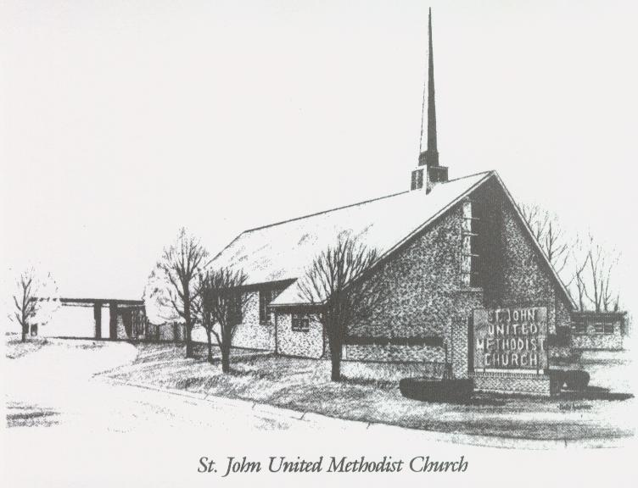
April 21, 2024

Church 270-683-6326
Email: office@stjohnum.org
Website: stjohnum.org
Pastor: Chris Toney
304-704-2910

Sunday School – 9:00 a.m. Sunday Worship – 10:00 a.m.
Lay Leader – Sondra Jones
Director of Music – Sharon Sauer
Organist – Ila Culp Pianist – Marty Shively
Liturgist – Tony Minton
Media Tech – Daniel Gray
Bishop – Leonard Fairley Dist. Supt. – Jay Smith
Secretary—Sondra Jones
S
INVITE~~RELATE~~NURTURE~~SEND FORTH
Our mission at St. John United Methodist Church
is to discover and invite all persons,
to relate them to Jesus Christ,
to nurture them in faith,
and to send them out to live as disciples,
making the community and
the world a better place to live.

