Announcements:
Sunday, May 14, Mother’s Day
10:00 am Worship Service
Wednesday, May 17
4:00 pm Bible Study
5:00 pm Choir Practice
Saturday, May 20
8:30 am Methodist Men’s Breakfast
Sunday, May 21, Graduation Sunday
9:00 am Sunday School
10:00 am Worship Service
11:00 am Graduation Luncheon (Cake Provided)
Tuesday, May 23
5:00 pm Supper Club @ Olive Garden
Wednesday, May 24
4:00 pm Bible Study
5:00 pm Choir Practice

**Yard Sale is June 3rd. If you have items to donate, feel free to drop them by the church on Mondays or Wednesdays during office hours, 9 to 4.

Prelude: Lighting of the Candles
Song of Welcome: Sweet, Sweet Spirit p.334
Greetings and Announcements
Praises
*Call to Worship: Apostle’s Creed p.881
*Hymn of Praise It Is Well with My Soul (v1,2,&3) p.377
*Greet Your Neighbor: Pass the Peace of Christ
Prayer Concerns
Pastoral Prayer & The Lord’s Prayer
Giving of Tithes and Offerings
*People’s Response: Doxology p.95
Anthem: St. John’s Choir Children’s Moment: Star Ralph

Scripture Reading: Acts 9: 31 Tony Minton
Sermon: "A Time of Peace" Rev. Dave Turner * *Hymn of Reflection: God Will Take Care of You(v2) p.130
*Sending Forth
*Postlude

*Congregation Standing
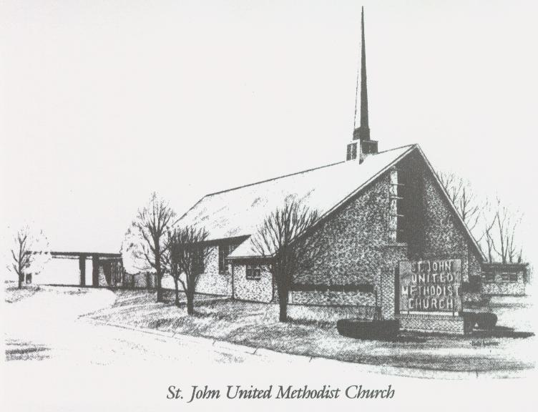
May 14, 2023
“A TIME OF PEACE”
Church 270-683-6326
Email: office@stjohnum.org
Pastor: David Turner
270-350-5360

Sunday School – 9:00 a.m. Sunday Worship – 10:00 a.m.
Lay Leader – Dana Gray
Director of Music – Sarah Elliott
Organist – Ila Culp Pianist – Marty Shively
Liturgist – Tony Minton
Media Tech – Daniel Gray
Bishop – Leonard Fairley Dist. Supt. – Jay Smith
Secretary—Sondra Jones
S
INVITE~~RELATE~~NURTURE~~SEND FORTH
Our mission at St. John United Methodist Church
is to discover and invite all persons,
to relate them to Jesus Christ,
to nurture them in faith,
and to send them out to live as disciples,
making the community and
the world a better place to live.

