Announcements:
Sunday, July 21
10:00 am Worship Service with VBS Special Music
11:00 am VBS Cookout/Pot-Luck
Monday, July 29
4:00 pm Family Life Mtg.
Thursday, August 1
5:00 pm Craft Fair/Car Show Mtg.
Sunday, August 4, Communion Sunday
9:00 am Sunday School
10:00 am Worship Service
Monday, August 5
7:45 pm Serving @ St. Benedict’s
Tuesday, August 6
4:00 pm UWF Mtg.

**A special THANK YOU to all the special people who volunteered before, during and after VBS. The children had a wonderful time “diving” into a deeper relationship with God and it could not have happened without YOU!!
Prelude: Lighting of the Candles
Greetings and Announcements
*Song of Welcome: Come, We That Love the Lord
(all verses) p.732
*Call to Worship: Apostle’s Creed p.881
Praises
*Hymn of Praise: Joyful, Joyful We Adore Thee
(v1,2, & 4) p.89
Special Music: Aaron Lundy
VBS Special Music
*Greet Your Neighbor: Pass the Peace of Christ
Prayer Concerns
Pastoral Prayer & The Lord’s Prayer
Giving of Tithes and Offerings
*People’s Response: Doxology p.95

Scripture Reading: Jonah 1: 1-4, 17 Tony Minton
Sermon: Pastor Chris Toney
*Hymn of Reflection: Come, Thou Fount of Every Blessing
(v1&3) p.400
*Sending Forth
*Congregation Standing
*Postlude

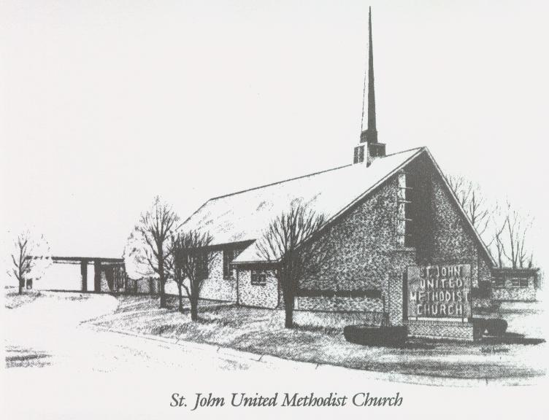

July 28, 2024

Church 270-683-6326
Email: office@stjohnum.org
Website: stjohnum.org
Pastor: Chris Toney
304-704-2910

Sunday School – 9:00 a.m. Sunday Worship – 10:00 a.m.
Lay Leader – Sondra Jones
Director of Music – Aaron Lundy
Organist – Ila Culp Pianist – Marty Shively
Liturgist – Tony Minton
Media Tech – Daniel Gray
Bishop – Leonard Fairley Dist. Supt. – Jay Smith
Secretary—Sondra Jones
S
INVITE~~RELATE~~NURTURE~~SEND FORTH
Our mission at St. John United Methodist Church
is to discover and invite all persons,
to relate them to Jesus Christ,
to nurture them in faith,
and to send them out to live as disciples,
making the community and
the world a better place to live.

